**FIT** **Lab Session 11**

***NED University of Engineering & Technology – Department of Software Engineering***

**Lab Session 11**

**OBJECT**

***Creating databases using Microsoft Access***

**USING MICROSOFT ACCESS**

**FAMILIARIZATION WITH SOME BASIC DATABASE RELATED TERMS**

* A ***record*** in a row on a datasheet and is a set of values defined by fields. In a mailing list table, each record would contain the data for one person as specified by the intersecting fields.
* A ***field*** is a column on a datasheet and defines a data type for a set of values in a table. For a mailing list table might include fields for first name, last name, address, city, state, zip code, and telephone number.
* A ***table*** is a grouping of related data organized in fields (columns) and records (rows) on a datasheet. By using a common field in two tables, the data can be combined. Many tables can be stored in a single database.
* A ***database*** is a collection of related information.

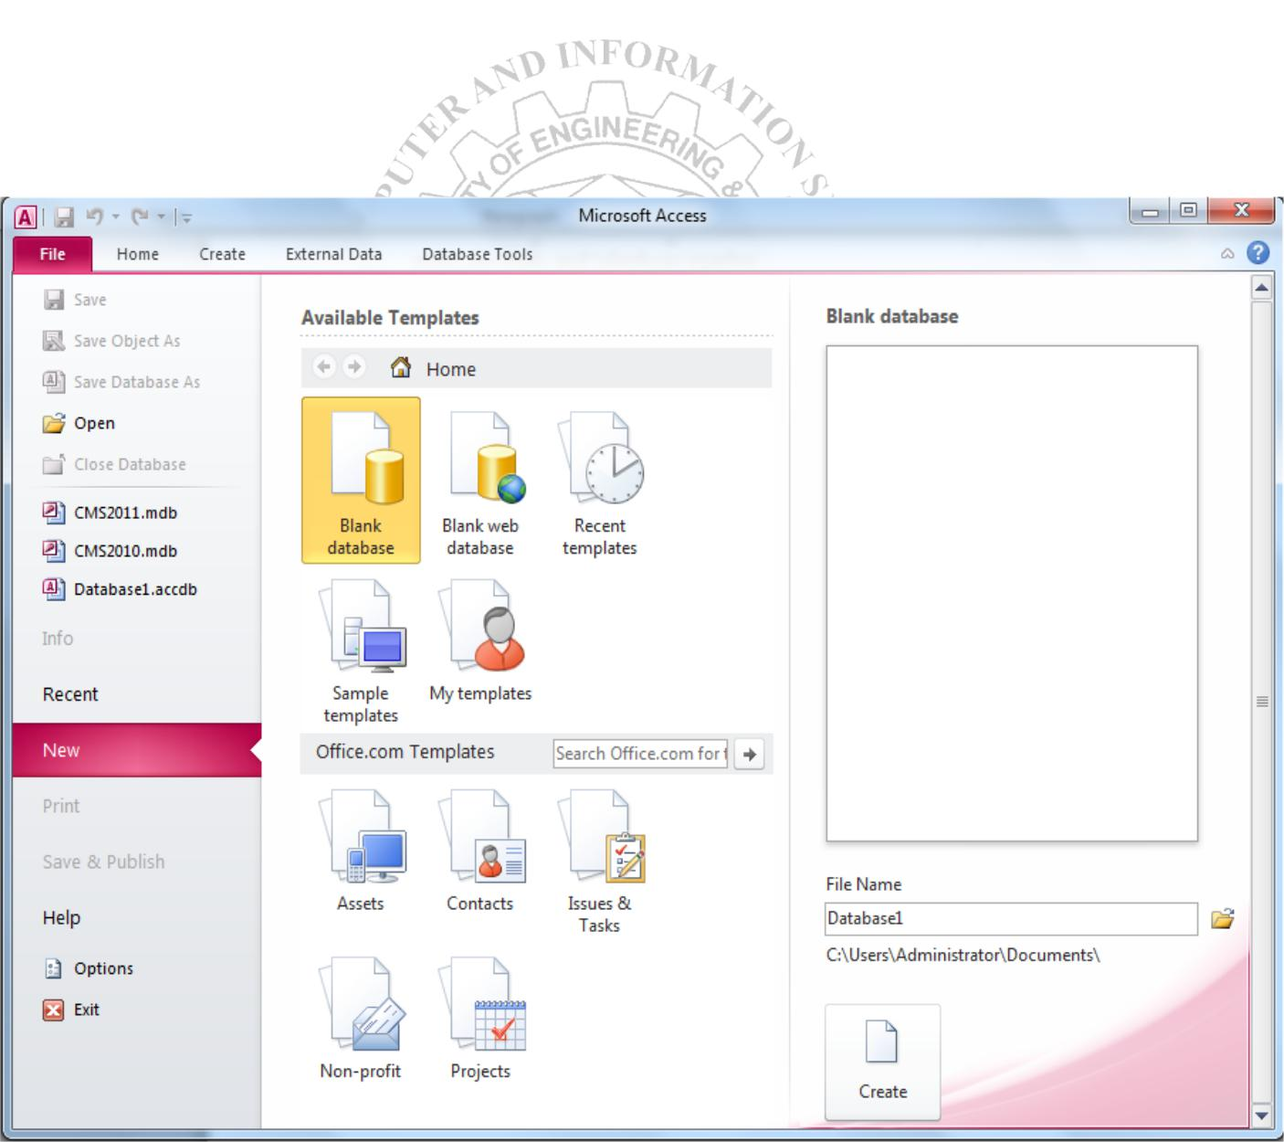

**Figure 11.1 MS Access Welcome window**

**FIT** **Lab Session 11**

***NED University of Engineering & Technology – Department of Software Engineering***

**GETTING STARTED**

After opening Access, you will be presented with two major options as shown in figure above. First if you are creating a new database or the second if you want to open and edit an existing database. Details about both of these choices are given below:

**Open an existing database**

If the database was opened recently on the computer, it will be listed in the File Menu either directly or inside *Recent* option. Highlight the database name and click *OK.* Otherwise, click Open (Ctrl + O) from File Menu, navigate to proper folder location, highlight the database name in the listing and click *OK.*

**Creating a new database**

Click *New* (Ctrl + N) option inside the File Menu. You will be presented with MS Access available database templates both offline and online and then you are required to select any one of them to create your new database. Some of the example offline database templates include Blank Database, Blank Web database, sample database etc. Some of the example online database templates include Assets, Contacts, Issues and Tasks etc. Unlike Word documents, Excel worksheets, and Power Point presentations, you must save an Access database before you start working on it. After selecting "Blank Access database" for example, you will first be prompted to specify a location and name for the database.

**SCREEN LAYOUTS Database Window**

The Database Window (figure 11.2) organizes all of the objects in the database e.g. Tables, Queries, Forms etc. The default table listing provides links for creating or modifying tables and will list all of the tables in the database when they have been added.

**Design View**

Design View (Figure 11.3) customizes the fields in the database so that data can be entered.

**Datasheet View**

The datasheet view (Figure 11.4) allows you to enter data into the database.

**FIT** **Lab Session 11**

***NED University of Engineering & Technology – Department of Software Engineering***

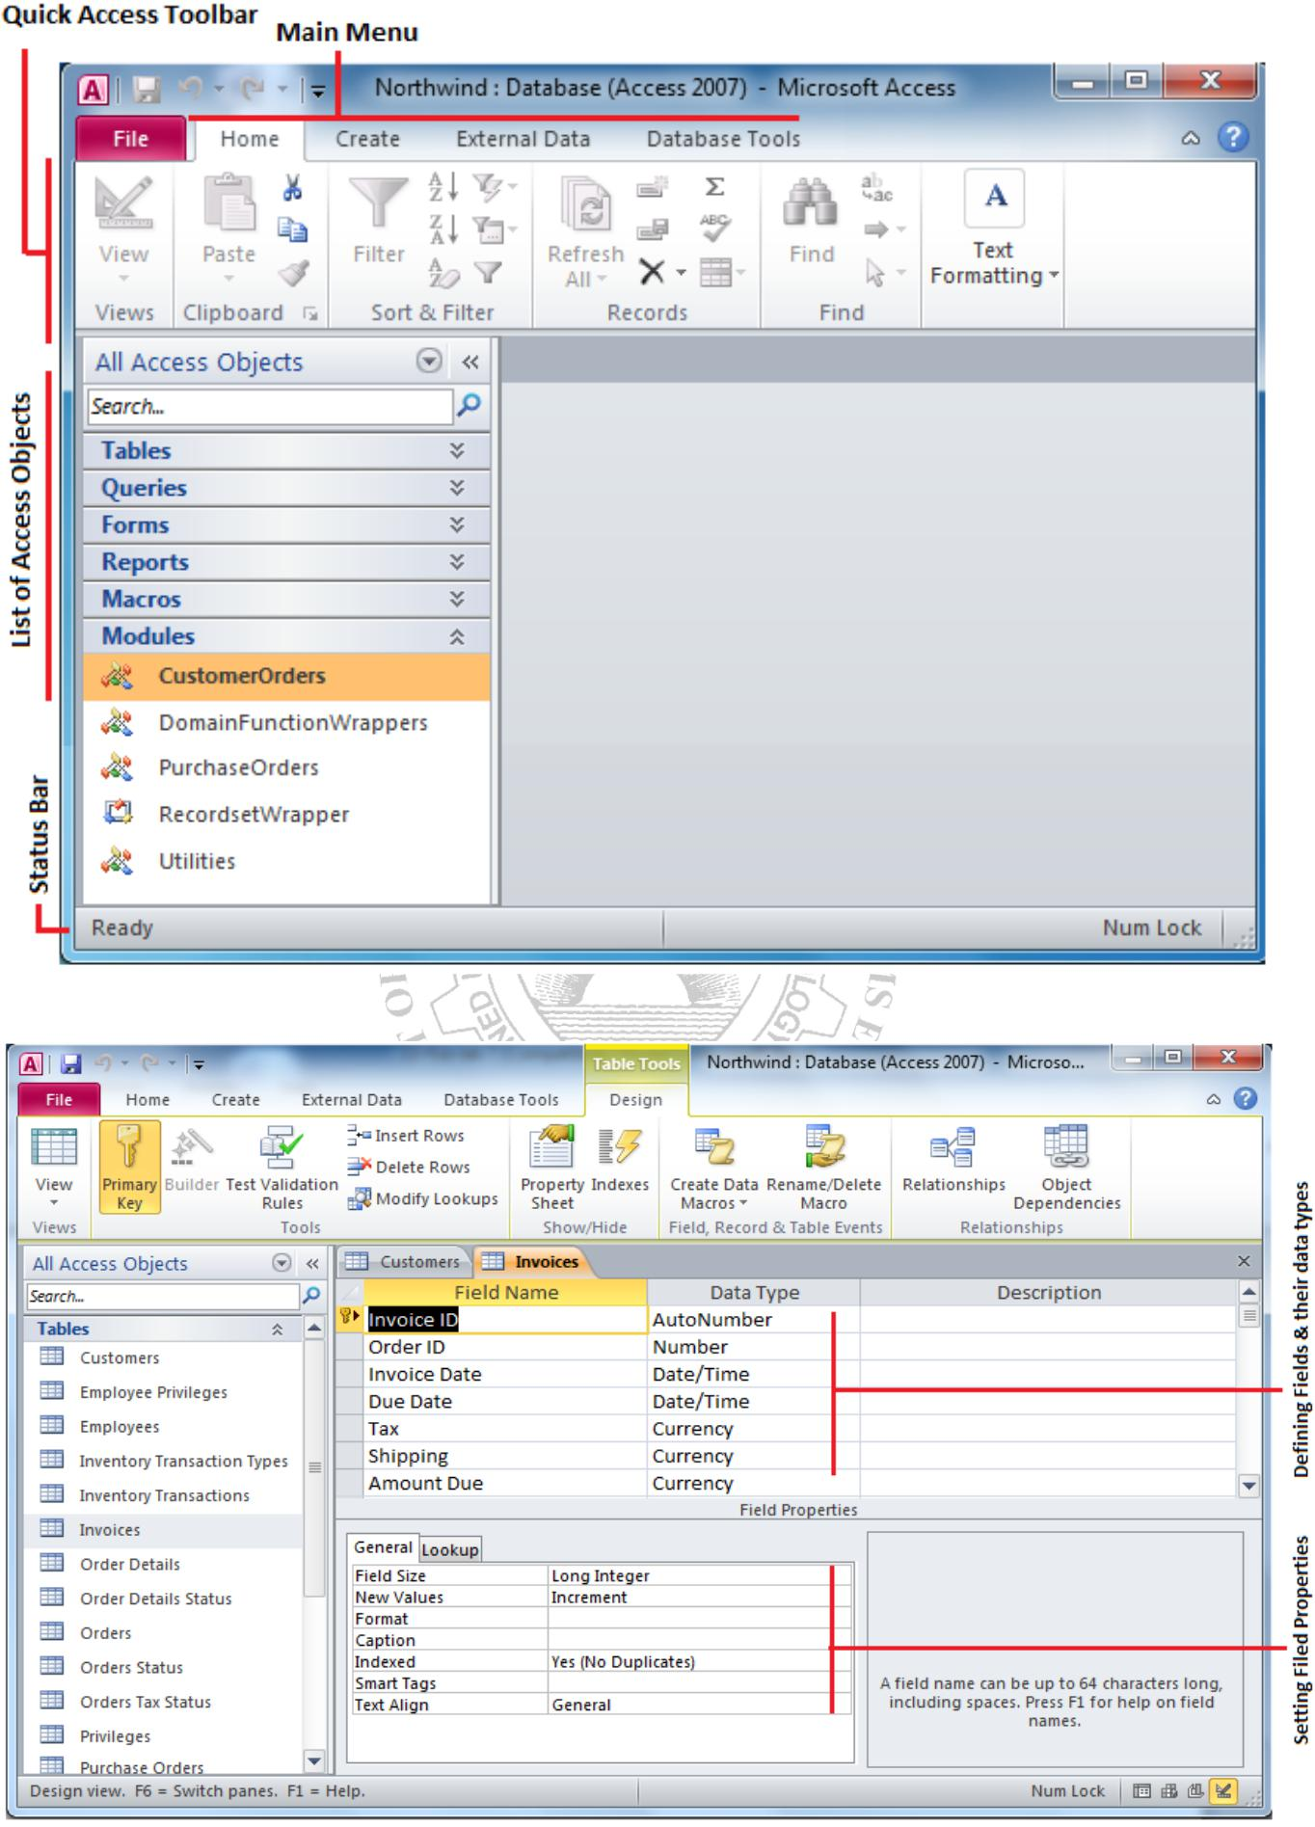

**Figure 11.2: Database Window**

**Figure 11.3: Design View**

**FIT** **Lab Session 11**

***NED University of Engineering & Technology – Department of Software Engineering***

**CREATING TABLES**

**Introduction to Tables**

Tables are grids that store information in a database similar to the way an Excel worksheet stores information in a workbook. To create a table Click Create from Main Menu. Access provides two ways to create a table for which there are icons Table and Table design. Double-click on any icon to create a table.

* ***Create table in Design view*** will allow you to create the fields of the table. This is themost common way of creating a table and is explained in detail below.
* ***Create table by entering data*** will give you a blank datasheet with just ID field and therest with unlabeled columns that looks much like an Excel worksheet. Enter data into the cells and click the *Save* button. After the table is saved, the empty cells of the datasheet are trimmed. The fields are given generic names such as "Field1", "Field2", etc. To rename them with more descriptive titles that reflect the content of the fields, change the view to Design view again and modify names as per requirements.

**Create a Table in Design View**

Design View will allow you to define the fields in the table before adding any data to the datasheet. The window is divided into two parts: a top pane for entering the field name, data type, and an option description of the field, and a bottom pane for specifying field properties as shown in (figure 11.3)

* ***Field Name*** *-*This is the name of the field and should represent the contents of the fieldsuch as "Name", "Address", "Final Grade", etc. The name cannot exceed 64 characters in length and may include spaces.
* ***Data Type*** is the type of value that will be entered into the fields.

o *Text* - The default type, text type allows any combination of letters and numbers up to a maximum of 255 characters per field record.

o *Memo* - A text type that stores up to 64,000 characters. o *Number* - Any number can be stored.

o *Date/Time* - A date, time, or combination of both.

o *Currency* - Monetary values that can be set up to automatically include a dollar sign ($) and correct decimal and comma positions.

o *AutoNumber* - When a new record is created, Access will automatically assign a unique integer to the record in this field. From the General options, select Increment if the numbers should be assigned in order or random if any random number should be chosen. Since every record in a datasheet must include at least one field that distinguishes it from all others, this is a useful data type to use if the existing data will not produce such values.

o *Yes/No* - Use this option for True/False, Yes/No, On/Off, or other values that must be only one of two.

o *OLE Object* - An OLE (Object Linking and Embedding) object is a sound, picture, or other object such as a Word document or Excel spreadsheet that is created in another program. Use this data type to embed an OLE object or link to the object in the database.

o *Hyperlink* - A hyperlink will link to an Internet or Intranet site, or another location in the database. The data consists of up to four parts each separated by the pound sign (#): DisplayText#Address#SubAddress#ScreenTip. The Address is the only required part of the string. Examples:

*Internet hyperlink example:* FGCU Home Page#http://www.fgcu.edu#

*Database link example:* #c:\My Documents\database.mdb#MyTable

**FIT** **Lab Session 11**

***NED University of Engineering & Technology – Department of Software Engineering***

* **Description** (optional) - Enter a brief description of what the contents of the field are.
* **Field Properties** - Select any pertinent properties for the field from the bottom pane.

**Field Properties**

Properties for each field are set from the bottom pane of the Design View window.

* **Field Size** is used to set the number of characters needed in a text or number field. Thedefault field size for the text type is 50 characters. If the records in the field will only have two or three characters, you can change the size of the field to save disk space or prevent entry errors by limiting the number of characters allowed. Likewise, if the field will require more than 50 characters, enter a number up to 255. The field size is set in exact characters for Text type, but options are given for numbers:

o**Byte** - Positive integers between 1 and 255

o**Integer** - Positive and negative integers between -32,7613 and 32,7613

1. **Long Integer (default)** - Larger positive and negative integers between -2 billion

and 2 billion.

o **Single** - Single-precision floating-point number o **Double** - Double-precision floating-point number

o**Decimal** - Allows for Precision and Scale property control

* **Format** confirms the data in the field to the same format when it is entered into thedatasheet. For text and memo fields, this property has two parts that are separated by a semicolon. The first part of the property is used to apply to the field and the second applies to empty fields.

**Primary Key**

Every record in a table must have a primary key that differentiates it from every other record in the table. In some cases, it is only necessary to designate an existing field as the primary key if you are certain that every record in the table will have a different value for that particular field. A social security number is an example of a record whose values will only appear once in a database table.

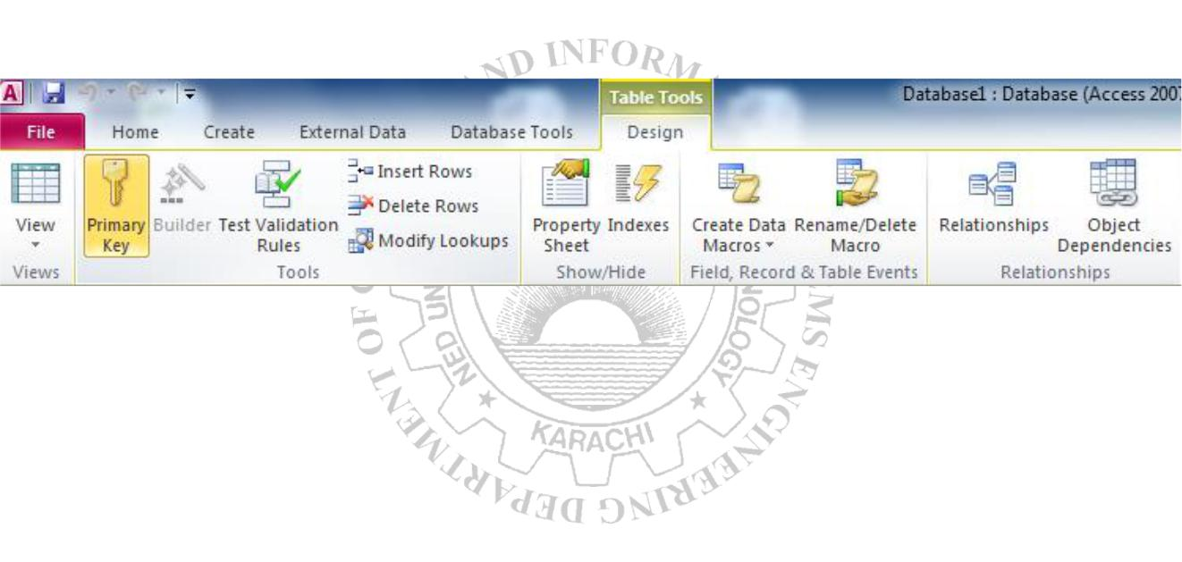

**Figure 11.5 Quick Access Toolbar – Table Tools**

Designate the primary key field by right-clicking on the record and selection *Primary Key* from the shortcut menu or select *Primary Key* from the Quick Access Toolbar as given in figure above. The primary key field will be noted with a key image to the left. To remove a primary key, repeat one of these steps.

**Indexes**

Creating indexes allows Access to query and sort records faster. To set an indexed field, select a field that is commonly searched and change the Indexed property to *Yes* *(Duplicates OK)* if multiple entries of the same data value are allowed or *Yes (No Duplicates)* to prevent duplicates.

**Field Validation Rules**

Validation Rules specify requirements (change word) for the data entered in the worksheet. A customized message can be displayed to the user when data that violates the rule setting is entered. Click the expression builder ("**...**") button at the end of the Validation Rule box to write the validation rule. Examples of field validation rules include *<> 0* to not allow zero values in the record, and *???* to only all data strings three characters in length.

**Input Masks**

An input mask controls the value of a record and sets it in a specific format. They are similar to the Format property, but instead display the format on the datasheet before the data is entered. For example, a telephone number field can formatted with an input mask to accept ten digits that are automatically formatted as "(555) 123-4567". The blank field would look like (___) ___-____. Add an input mask to a field by following these steps:

* In design view, place the cursor in the field that the input mask will be applied to.
* Click in the white space following *Input Mask* under the *General* tab.
* Click the "**...**" button to use the wizard or enter the mask, (@@@) @@@-@@@@,

into the field provided.

**DATASHEET RECORDS**

**Adding Records**

Add new records to the table in datasheet view by typing in the record beside the asterisk

(*) that marks the new record.

**Editing Records**

To edit records, simply place the cursor in the record that is to be edited and make the necessary changes. Use the arrow keys to move through the record grid. The previous, next, first, and last record buttons at the bottom of the datasheet are helpful in maneuvering through the datasheet.

**Deleting Records**

Delete a record on a datasheet by placing the cursor in any field of the record row and select *Delete Record* from the menu bar or click the *Delete* button on the Quick Access toolbar.

**Adding and Deleting Columns**

Although it is best to add new fields (displayed as columns in the datasheet) in design view because more options are available, they can also be quickly added in datasheet view. Highlight the column that the new column should appear to the left of by clicking its label at the top of the datasheet and press right click then select *Insert field* from the dropdown menu. Entire columns can be deleted by placing the cursor in the column and selecting *Delete field* from the dropdown menu.

**Freezing and unfreezing Columns**

Similar to freezing panes in Excel, columns on an Access table can be frozen. This is helpful if the datasheet has many columns and relevant data would otherwise not appear on the screen at the same time. Freeze a column by placing the cursor in any record in the column and select *Freeze fields* from the right click dropdown men. Select the same option to unfreeze a single column or select *Unfreeze All fields.*

**FIT** **Lab Session 11**

***NED University of Engineering & Technology – Department of Software Engineering***

**Finding Data in a Table**

Open the table in datasheet view. Place the cursor in any record in the field that you want to search and select *Home|Find (Ctrl + F)...* from the Quick Access toolbar. Enter the value criteria in the *Find What:* box. From the *Look In:* drop-down menu, define the area of the search by selecting the entire table or just the field in the table you placed your cursor in during step 2. Select the matching criteria from *Match:* to and click the *More >>* button for additional search parameters. When all of the search criteria are set, click the *Find Next* button. If more than one record meets the criteria, keep clicking *Find Next* until you reach the correct record.

**Sorting & Filtering**

Sorting and filtering allow you to view records in a table in a different way either by reordering all of the records in the table or view only those records in a table that meet certain criteria that you specify.

**Sorting **

In table datasheet view, place the cursor in the column that you want to sort by. Select *Ascending* or *Descending* from the Quick Access toolbar under Home main menu or clickthe *Sort A to Z* or *Sort Z to A* from the dropdown menu.

To sort by more than one column (such as sorting by date and then sorting records with the same date alphabetically), highlight the columns by clicking and dragging the mouse over the field labels and select one of the sort methods stated above.

**Filter by Selection **

This feature will filter records that contain identical data values in a given field such as filtering out all of the records that have the value "Smith" in a name field. To Filter by Selection, place the cursor in the field that you want to filter the other records by and click the *Selection* button inside Home main menu on the toolbar or directly select the criteria from right click dropdown menu.

**Filter by Form **

If the table is large, it may be difficult to find the record that contains the value you would like to filter by so using Filter by Form may be advantageous instead. This method creates a blank version of the table with drop-down menus for each field that each contains the values found in the records of that field.

The following methods can be used to select records based on the record selected by that do not have exactly the same value. Type these formats into the field where the drop-down menu appears instead of selecting an absolute value.

**Saving A Filter**

The filtered contents of a table can be saved as a query by selecting *Advanced|Save As* *Query*. Enter a name for the query and click *OK.* The query is now saved within thedatabase.

**Remove a Filter **

To view all records in a table again, click the depressed *toggle Filter* button.

**EXERCISES**

Create the following tables in Microsoft Access:

Table1: *Student* (containing fields: *Student ID, First Name, Last Name, Department* and *Class).*

Table2: *Marks* (containing fields: *Student ID, ITC, Mathematics, English, Electronics,* *Physics).*

Select appropriate primary keys and define appropriate relationship for these two tables.

Add some sample data to the tables and make a hard copy of the tables created.

**Attach your printout here.**

**FIT** **Lab Session 12**

***NED University of Engineering & Technology – Department of Software Engineering***

**Lab Session 12**

**OBJECT**

***Creating queries, forms and reports in Microsoft Access***

**INTRODUCTION TO QUERIES**

Queries select records from one or more tables in a database so they can be viewed, analyzed, and sorted on a common datasheet. The resulting collection of records, called a dynaset (short for dynamic subset), is saved as a database object and can therefore be easily used in the future. The query will be updated whenever the original tables are updated. Types of queries are *select queries* that extract data from tables based on specified values, *find duplicate* queries that display records with duplicate values for one or more of thespecified fields, and *find unmatched* queries display records from one table that do not have corresponding values in a second table.

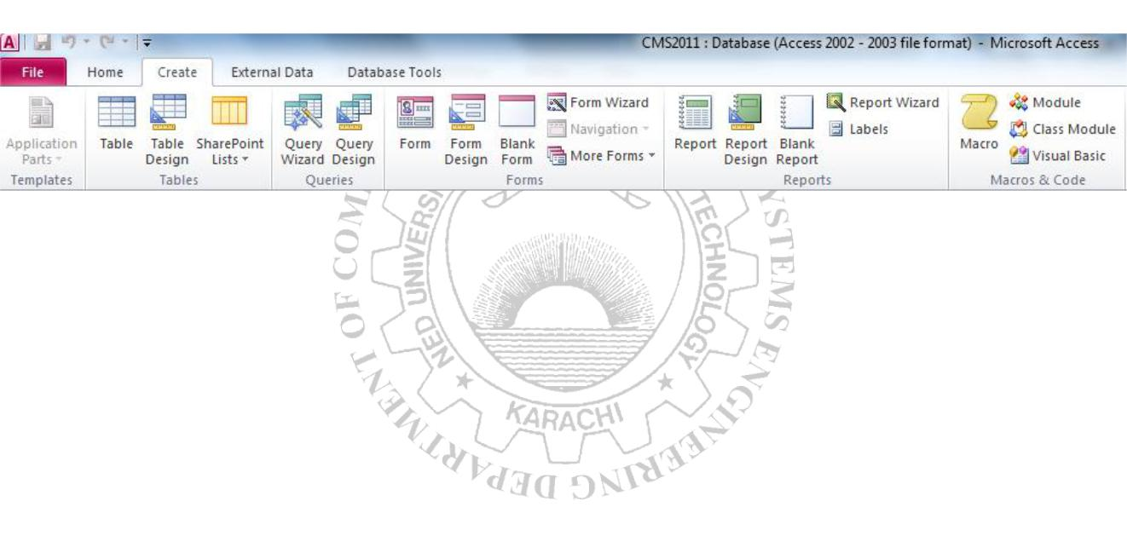

**Figure 12.1 Create Menu Quick Access Toolbar**

**Create a Query in Design View**

From the Create Main Menu as in figure 12.1, click the *Query Design icon*. Select tables and existing queries from the *Tables* and *Queries* tabs and click the *Add* button to add each one to the new query. Click *Close* when all of the tables and queries have been selected. Add fields from the tables to the new query by double-clicking the field name in the table boxes or selecting the field from the *Field:* and *Table:* drop-down menus on the query form. Specify sort orders if necessary.

Enter the criteria for the query in the *Criteria:* field. The *Expression Builder *can also be used to assist in writing the expressions. After you have selected all of the fields and tables, click the *Run* button on the toolbar. Save the query by clicking the *Save* button.

**Query Wizard**

Click the *Create query by using wizard* icon in the database window to have Access step you through the process of creating a query. From the first window, select fields that will be included in the query by first selecting the table from the drop-down *Tables/Queries* menu. Select the fields by clicking the **>** button to move the field from the Available Fields list to Selected Fields. Click the double arrow button **>>** to move all of the fields to Selected Fields. Select another table or query to choose from more fields and repeat the process of moving them to the Selected Fields box. Click *Next >* when all of the fields have been selected. On the next window, enter the name for the query and click *Finish.*

**FIT** **Lab Session 12**

***NED University of Engineering & Technology – Department of Software Engineering***

**Find Duplicates Query**

This query will filter out records in a single table that contain duplicate values in a field. Click the *New* button on the Queries database window, select *Find Duplicates Query* *Wizard* from the *New Query* window and click *OK*. Select the table or query that the findduplicates query will be applied to from the list provided and click *Next >.* Select the fields that may contain duplicate values by highlighting the names in the Available fields list and clicking the **>** button to individually move the fields to the Duplicate-value fields list or **>>** to move all of the fields. Click *Next >* when all fields have been selected. Select the fields that should appear in the new query along with the fields selected on the previous screen and click *Next >.* Name the new query and click *Finish*.

**Delete a Query**

To delete a query, select the required query and press the *Delete* key on the keyboard.

**FORMS**

Forms are used as an alternative way to enter data into a database table.

**Create Form by Using Wizard**

From the Create Main Menu as in figure 12.1, click *Form wizard* option in Forms section. From the *Tables/Queries* drop-down menu, select the table or query whose datasheet the form will modify. Then, select the fields that will be included on the form by highlighting each one the *Available Fields* window and clicking the single right arrow button **>** to move the field to the *Selected Fields* window. To move all of the fields to Select Fields, click the double right arrow button **>>**. If you make a mistake and would like to remove a field or all of the fields from the Selected Fields window, click the left arrow **<** or left double arrow

* buttons. After the proper fields have been selected, click the *Next >* button to move on to the next screen. On the second screen, select the layout of the form.
* **Columnar** - A single record is displayed at one time with labels and form fields listedside-by-side in columns.
* **Justified** - A single record is displayed with labels and form fields are listed across thescreen.
* **Tabular** - Multiple records are listed on the page at a time with fields in columns andrecords in rows.
* **Datasheet** - Multiple records are displayed in Datasheet View

Click the ***Next*** **>** button to move on to the next screen. Select a visual style for the form from the next set of options and click *Next >*. On the final screen, name the form in the space provided. Select "Open the form to view or enter information" to open the form in Form View or "Modify the form's design" to open it in Design View. Click *Finish* to create the form.

**Adding Records Using A Form**

Input data into the table by filling out the fields of the form. Press the *Tab* key to move from field to field and create a new record by clicking *Tab* after the last field of the last record. A new record can also be created at any time by clicking the *New Record* button  at the bottom of the form window. Records are automatically saved as they are entered so no additional manual saving needs to be executed.

**FIT** **Lab Session 12**

***NED University of Engineering & Technology – Department of Software Engineering***

**Editing Forms**

The following points may be helpful when modifying forms in Design View:

* ***Grid lines*** - By default, a series of lines and dots underlay the form in Design View soform elements can be easily aligned. To toggle this feature on and off right click and select Grid.
* ***Resizing Objects*** - Form objects can be resized by clicking and dragging the handles onthe edges and corners of the element with the mouse.
* ***Change form object type*** - To easily change the type of form object without having tocreate a new one, right click on the object with the mouse and select *Change To* and select an available object type from the list.
* ***Label/object alignment*** - Each form object and its corresponding label are bounded andwill move together when either one is moved with the mouse. However, to change the position of the object and label in relation to each other (to move the label closer to a text box, for example), click and drag the large handle at the top, left corner of the object or label.
* ***Tab order*** - Alter the tab order of the objects on the form by selecting*Tab Order*fromdesign Menu when Form is active. Click the gray box before the row you would like to change in the tab order, drag it to a new location, and release the mouse button.
* ***Form Appearance*** - Change the background color of the form by clicking the*Shape**Fill* button on the format menu inside Form Design. Change the color of individualform objects by highlighting one and selecting a color from *Color* palette on the formatting toolbar. The font and size, font effect, font alignment, border around each object, the border width, and a special effect can also be modified using the formatting toolbar buttons inside Form Design Tools.

**Form Controls**

This section explains the uses for other types of form controls including lists, combo boxes, checkboxes, option groups, and command buttons.

* ***List and Combo Boxes:*** If there are small, finite number of values for a certain field ona form, using combo or list boxes may be a quicker and easier way of entering data. These two control types differ in the number of values they display. List values are all displayed while the combo box values are not displayed until the arrow button is clicked to open.
* ***Check Boxes and Option Buttons:*** Use check boxes and option buttons to displayyes/no, true/false, or on/off values. Only one value from a group of option buttons can be selected while any or all values from a check box group can be chosen. Typically, these controls should be used when five or fewer options are available. Combo boxes or lists should be used for long lists of options.
* ***Command Buttons:*** Command buttons provide you with a way of performing action(s)by simply clicking them. When you choose the button, it not only carries out the appropriate action, it also looks as if it's being pushed in and released.

**Reports**

Reports will organize and group the information in a table or query and provide a way to print the data in a database.

**EXERCISES**

Create the customize form and report of following tables in Microsoft Access:

Table1: *Student* (containing fields: *Student ID, First Name, Last Name, Department* and *Class).*

Table2: *Marks* (containing fields: *Student ID, ITC, Mathematics, English, Electronics,* *Physics).*

**Attach your printout here.**

**FIT** **Lab Session 12**

***NED University of Engineering & Technology – Department of Software Engineering***

**Using the Wizard**

From the Create Main Menu as in figure 12.1, click Report Wizard option in the Reports section. Select the information source for the report by selecting a table or query from the *Tables/Queries* drop-down menu. Then, select the fields that should be displayed in thereport by transferring them from the *Available Fields* menu to the *Selected Fields* window using the single right arrow button **>** to move fields one at a time or the double arrow button **>>** to move all of the fields at once. Click the *Next >* button to move to the next screen.

Select fields from the list that the records should be grouped by and click the right arrow button **>** to add those fields to the diagram. Use the *Priority* buttons to change the order of the grouped fields if more than one field is selected. Click *Next >* to continue. If the records should be sorted, identify a sort order here. Select the first field that records should be sorted by and click the A-Z sort button to choose from ascending or descending order. Click *Next >* to continue. Select a layout and page orientation for the report and click *Next*

* Select a color and graphics style for the report and click *Next >.* On the final screen, name the report and select to open it in either Print Preview or Design View mode. Click the *Finish* button to create the report.

**Create in Design View**

Click Report Design button in the Reports section of create access toolbar and you will be presented with a blank grid. Automatically properties window will open for this newly being created report. Click on Record Source property combo box and you will be presented with the list of available tables and queries. Choose the data source of the report from the drop-down menu and click *OK.* Design the report in much the same way you would create a form. For example, double-click the title bar of the Field Box to add all of the fields to the report at once. Then, use the handles on the elements to resize or move them to different locations, and modify the look of the report as per your requirements.

**FIT** **Lab Session 13**

***NED University of Engineering & Technology – Department of Software Engineering***

**Lab Session 13**

**OBJECT**

***Familiarization with the environment of Microsoft Power Point***

**USING POWER POINT**

A user can communicate information better and more easily with a PowerPoint presentation. A presentation is a series of slides that a user creates by using PowerPoint. The more important the message, the clearer the presentation should be. Also for larger audience, the message must be easy to grasp.

The facilities PowerPoint provides are discussed below:

**Creating a New Power Point Presentation**

***Presentation Type:*** Open Power Point and you will be prompted by a dialog box withdifferent choices. These choices are explained below. If Power Point is already open or this box does not appear, select *File|New* from the menu bar.

* *Blank Presentation:*Select Blank Presentation to build the presentation from scratch withno preset graphics or formatting.
* *Recent Templates:* This option shows all the templates used previously during the currentsession of your work.
* *Sample Templates:* This option provides templates and ideas for a variety of presentationtypes. Page through the wizard to select the required type.
* *Themes:* Power Point provides many templates with different backgrounds and textformatting to begin your presentation. Preview each design by highlighting the template name in the menu. Double click on the chosen design to open the required template.
* *My Template:* This option allows you to insert and/or create your own design template.
* *New from Existing:* This option lets you convert the older version power point files intothe current version. Then you can save it with the new format by using the *File|Save*

option from the menu bar.

To open an existing Power Point presentation, select *File|Open* option from the menu bar. Select the folder in which the file is located from the Look in: drop-down menu and highlight the file on the list. Click Open to open the presentation.

**Screen Layout Views**

Power Point gives you three screen layouts for constructing or viewing your presentation. These can be selected by using the icons given in the bottom right corner, or you can go to the *View* menu and select these options from the Presentation View section.

|  |  |  |  |
| --- | --- | --- | --- |
| **FIT** | |  | **Lab Session 13** |
| ***NED University of Engineering & Technology – Department of Software Engineering*** | | | |
|  |  |  |  |
|  | normal | slide show |  |
|  |  |  |  |

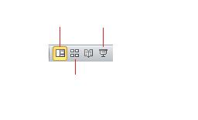

slide sorter

**Figure 13.1: Screen Views**

* *Normal View*:This screen is split into three sections showing the presentation window onthe left, the slide in the main window, and notes at the bottom. The presentation window can further be viewed in two different ways:

o *Outline View****:***The presentation outline is displayed on the majority of the screen with small windows for the slide and notes. This view is recommended for editing text.

o *Slide View:*The slide view displays each slide on the screen and is helpful for adding images, formatting text, and adding background styles.

* 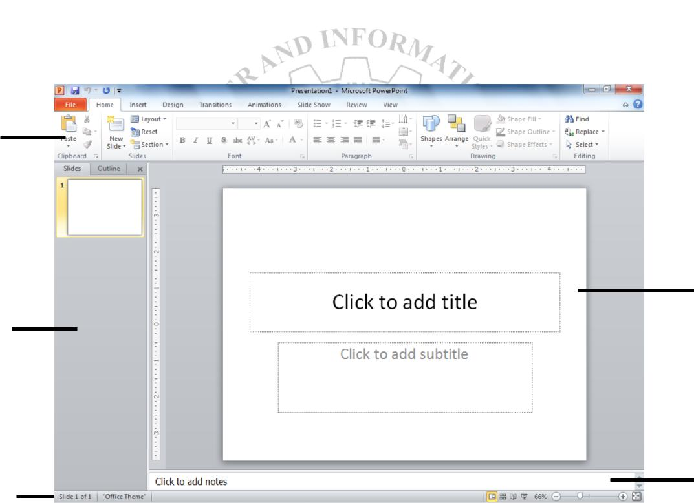*Slide Sorter View:*A small image of each slide is displayed in Slide Sorter view. Slidescan easily be ordered and sorted from this screen.

menu bar

slide window

presentation

window

notes window

status bar

screen views

**Figure 13.2: The Power Point screen layout in Normal View**

Click the *Slide Show* button to view the full-screen slide show.

**Working with Slides**

***Insert a New Slide:***In the Normal View, select the slide you want the new slide to appearafter by clicking the slide's number.Select *Home|NewSlide* from the menu bar. Choose the page layout from the window.

**FIT** **Lab Session 13**

***NED University of Engineering & Technology – Department of Software Engineering***

***Applying a Design Template:***To add a design template or change the existing one, select*Design* menu, and choose the template from the given options in the Themes section. If youwant to change the design of only one slide, then right click on the chosen theme and select ‘Apply to Selected Slide’ option.

***Changing Slide Layouts:***To change the layout template of the slide, select*Home|Layout*fromthe menu bar. Select one of the layout thumbnail images.

***Reordering Slides:***To reorder a slide in Slide Sorter View, simply click on the slide you wishto move and drag it to the new location. In Normal or Outline View, click the slide icon beside the number of the slide you want to move and drag the icon to a new location.

***Hide Slides:***If you do not want a slide to appear during the slide show, but do not want todelete the slide as it may be used later, the slide can be hidden by selecting *SlideShow|HideSlide* from the menu bar. To add the slide back to the slide show, select *SlideShow|HideSlide* again.

***Create a Custom Slide Show:***The Custom Slide Show feature allows you to select the slidesyou want to display in the slide show if not all the slides should be used. For this, select *Slide* *Show|Custom Slide Show|Custom Shows* menu bar; Click the *New...* button in the *Custom Shows* window; In the *Define Custom Show* window, type a name for the slide in the *Slide show name* field; Add slides to the custom show by highlighting them in the *Slides in presentation* window and clicking the *Add*>> button. Those slides will then appear in the *Slides in custom show* window; To remove slides from the custom show, highlight theirnames in the *Slides in custom show* window and click the *Remove* button; To reorder slides in the custom show, highlight the slide that should be moved and click the up and down arrows to change its order in the show; Click *OK* when finished; Click the *Show* button on the Custom Shows window to preview the custom slide show and click *Close* to exit.

***Edit a Custom Slide Show:***Select*Slide Show|Custom Slide Show|Custom Shows*from themenu bar and then choose the custom show that needs to be edited from the window that appears on screen.To edit, click on the *Edit...* button; to delete a show, highlight the name and click *Remove*; to create a copy of a show, click the *Copy* button. The copy can then be renamed by clicking the *Edit...* button; Click the *Show* button to preview the custom slide show and click *Close* to exit.

**Adding Contents**

***Bulleted Lists on Design Templates:***Bulleted lists allow you to clearly display the mainpoints of your presentation on slides. The text boxes on design templates already include bulleted lists. Click the place holder on the slide to begin adding text and press the *ENTER* key to return to the next line and add a new bulleted item. To go to the next line without adding another bullet, hold down the *SHIFT* key while pressing *ENTER*.

***Additional Bulleted List:***In slide view, create a text box by selecting*Insert|Text Box*fromthe menu bar. Thendraw the text box on the slide by holding down the left mouse button while you move the mouse until the box is the size you want it. Select the Bullets icon from the *Home* menu to insert new bullets in the text box. In order to change the formatting of bullets, click on the arrow besides the Bullets icon and select the *Bullets and Numbering…*

**FIT** **Lab Session 013**

***NED University of Engineering & Technology – Department of Software Engineering***

option. This opens a new window, from where you can change the size and color of the bullets. You can also click the *Picture* button to view the *Picture Bullet* window. Select one of the bullets and click *OK*.

*-OR-*

Click the *Customize* button to select any character from the fonts on the computer. Select a symbol font such as Wingdings or Webdings from the *Bulletsfrom* drop-down menu for the best selection of icons. Click on the characters in the grid to see them larger. Click *OK* when you have chosen the bullet you want to use.Click *OK* on the *Bullets and Numbering* window and use the same methods described in the "Bulleted Lists on Design Templates" to enter text into the bulleted list.

***Bulleted Lists and New Slides from an Outline:***In*Normal*or*Outline*view, text can easilybe entered in the outline window and new slides are automatically added. Next to the *Slide 1* icon, type the title of the slide. The text you type beside the slide icons will be the large-type titles on each slide.Press *ENTER* to type the next line. This will automatically create a new slide. To create a bulleted list for the first slide, press the *TAB* key or click the *demote* button on the *More Buttons* menu accessible by clicking the "triple arrow" button at the end of the formatting toolbar.

*-OR-*

Press *ALT+SHIFT+Right Arrow* to demote the selection to a bulleted list item; Continue entering text for the bulleted list, pressing *ENTER* at the end of each line to create a new bullet; Create a multilevel list by executing the demote action again to create a bulleted sub list. Press the *promote*button on the *More Buttons* menu or press *ALT+SHIFT+Left* *Arrow*to return to the original list; Create a new slide by executing the *promote* action until anew slide icon appears; Continue creating new slides and bulleted lists by using the demote and promote actions until the presentation is completed. Use the formatting instructions below to format the lists.

If there is more than one bulleted list on the slide, the lists will be designated by numbers enclosed in black boxes. The example below shows the slide created from the outline on the left. The bulleted list on the left side of the slide is labeled list "1" on the outline and the list on the right is labeled list "2". When typing the outline, begin typing in the new list by pressing *CTRL+ENTER*. In this example, *CTRL+ENTER* was pressed after typing "Access".

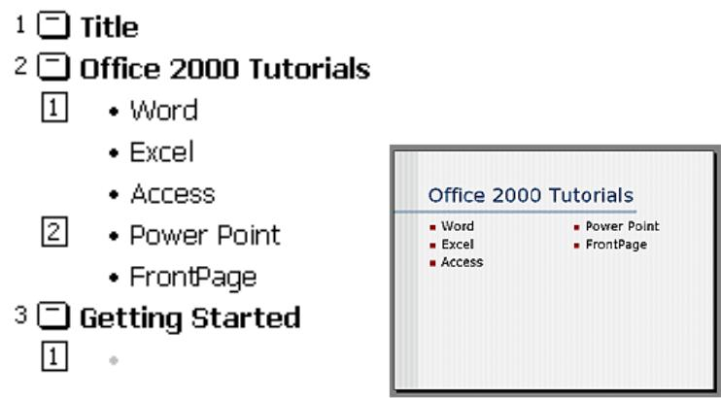

**Figure 13.3**

***Adding Notes:***From*Normal View,*notes can be added to the slide. These notes will not beseen on your presentation, but they can be printed out on paper along with the slide. This can be done by selecting *File/Print* menu, then under the Settings, in the second drop down menu, select the option ‘Notes Pages’.

**FIT** **Lab Session 14**

***NED University of Engineering & Technology – Department of Software Engineering***

**Lab Session 14**

**Object:**

***To learn the concept of Action Buttons and Invisible Buttons***

Action Buttons

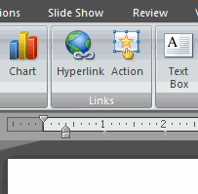In PowerPoint, you have the ability to link to a webpage, email address, file, slide in the same presentation, and slide in a different presentation. You can do all of this using two tools called **hyperlinks** and **action buttons**.  
  
In this lesson, you will learn how to insert hyperlinks using text and objects, as well as how to insert an action button.

Inserting action buttons

In addition to hyperlinks, another tool you can use to connect to a webpage, file, email address, or slide is called an **action button**, or action link. **Action buttons** are **built-in button shapes** you can add to a presentation and use as hyperlinks. When someone clicks or moves over the button, the action can occur.

Hyperlinks and action buttons are closely connected and can do many of the same things. Action buttons are used most for self-running presentations, such as those at a trade show booth or kiosk.

To insert an action button on all slides:

* Select the **View** tab.
* Click the **Slide Master** command in the Presentation Views group. The slide master view will appear.
* Select slide 1, the slide master. Changes to this slide will appear on all slides in the presentation.
* Select the **Insert** tab.
* Click the **Shapes** command in the Illustrations group.

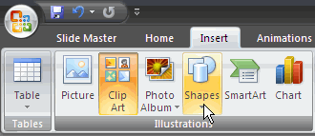

* Select an **action button** from the bottom of the list. In this example, we will select the **Home** action button.

**FIT** **Lab Session 14**

***NED University of Engineering & Technology – Department of Software Engineering***

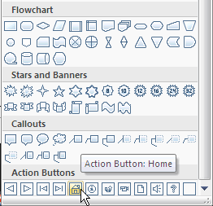

* Insert the shape onto the slide. The Actions Setting dialog box will appear.

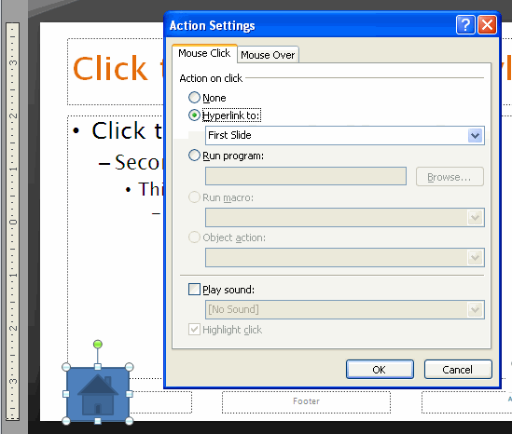

* + Select the **Mouse Click** or **Mouse Over** tab. Use the Mouse Click tab to set actions to occur when you click, and use the Mouse Over tab to set actions to occur when you move the cursor over the action button. In this example, we will leave the Mouse Click tab selected.
  + In the **Action on click** section, click **None** or **Hyperlink to**.
    - If you click **None**, the shape will have no action associated with it.
    - If you click **Hyperlink to:**, select an option from the menu. The hyperlink options work the same for action buttons as they do for traditional hyperlinks.

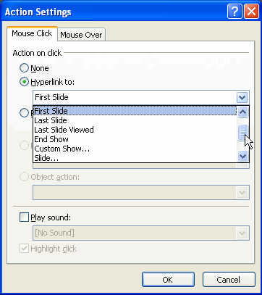 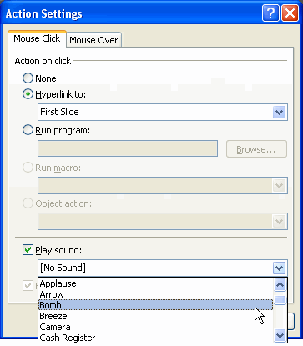

* + Click **Play Sound** if you wish to play a sound when the action button is clicked.
    - Select a sound from the drop-down menu.
* Click **OK**.

Action buttons do not have to be inserted on master slides. You can insert an action button on one slide, if you wish.

**FIT** **Lab Session 14**

***NED University of Engineering & Technology – Department of Software Engineering***

**To edit the action button:**

* Select the action button.
* Select the **Insert** tab.
* Click the **Action** command in the Links group. The Actions Settings dialog box will appear.

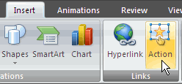

* Edit the action or hyperlink.
* Click **OK**.

When the action button is selected, the **Format** tab is available because it is a shape. You can change the shape style or color so it matches the color scheme of the slide from this tab.

***Video:***To add a video to your presentation select*Insert|Video|Video from File*or to insert avideo from Microsoft's gallery choose *Insert|Video|Clip Art Video*. Select the video file and click *OK.*

***Audio:***To add sound to your presentation, select*Insert|Audio|Audio from File*or*Clip Art**Audio*. Select a sound file and click *OK*.

**Graphics**

The Drawing Toolbar provides many commands for creating and editing graphics. Select *Insert* menu to choose the different tools as explained below:

***Adding Clip Art:***Select*Insert|Clip Art*from the menu bar, and use various options to insert,preview and edit the clips.

***Adding Picture or Photo Album:***To add a photo or graphic from a file, select*Insert|Picture*from the menu bar. Choose the file and insert it. Similarly, in order to insert a complete interactive photo album to the slide, select *Insert|Photo Album* option.

***Adding Shapes:***The Shapes menu allows you to add a number of geometrical shapes, arrows,flow chart elements, stars, and other graphics on a slide. Select *Insert|Shapes* from the menu bar, and choose one of the different shapes provided in the drop down menu.

***Adding Action Buttons:*** Use the action button toolbar to add functioning buttons to slides ina presentation. Select *Insert|Shape* from the menu bar and choose the *Action Buttons*given in the menu. As soon as the button is placed on the slide, the Action Settings window will appear on screen. Set the actions under either the *Mouse Click* or *Mouse Over* tabs. Actions specified for Mouse Click will execute when the button is clicked on the slide while actions for Mouse Over will occur when the mouse pointer hovers over the button. Select an action for the button by choosing a *Hyperlink to* destination. If you want a sound to be played when the button is clicked, check the *Play sound* box and choose a sound from the drop-down menu. Click *OK* when finished. If the window does not appear, first click on the action button to select it. Then select *Insert|Actions* option to open the Action Settings window. The button on the slide can be resized using the white box handles and the depth of the button can be changed by dragging the yellow diamond.

**FIT** **Lab Session 14**

***NED University of Engineering & Technology – Department of Software Engineering***

***Adding WordArt:***Add headlines in striking colors and shapes to your presentation usingWord Art.Select *Insert|WordArt* from the menu bar to choose a Word Art style from the listing.

***Adding Charts:*** A graph or a chart can be used in a presentation to highlight its activity.Select *Insert|Chart* from the menu bar. A window appears with different types of charts available in the software. Select any one, and click OK. A spreadsheet opens up, which lets you edit the values and range of the chart as per user requirement.

***Adding SmartArt:*** SmartArt Graphics include different types of lists, cycles, hierarchies,relationships, etc. that may be useful in a technical presentation. Select *Insert|SmartArt* from the menu bar, and then choose the required options from the window.

***Slide Animation:***Several animations for slide objects are available through*Animation*menuon the menu bar. First, select the text box or graphic that will be animated. Select one of the options from the ‘Animations’ section. To select a different animation or turn the animation off, select the appropriate choice from the same menu. You can also change the duration of your animation by specifying the number of seconds in the ‘Duration’ box. The ‘Delay’ option can be used to delay or stop your animation from appearing for the specified number of seconds.

***Slide Transitions:***Select*Transition*tab from the menu bar. From the‘Transition to ThisSlide’ section, choose a transition and notice the preview after the transition is selected. The speed or duration of transition can be changed by entering the time value in the ‘Duration’ box. You can check the "On mouse click" checkbox for the slide transition to occur by clicking the mouse or using keystrokes, or check the "After:" checkbox and a number of seconds if the transition should occur automatically. Select a *Sound* if necessary and check the *Loop until next sound* if it should keep repeating until the next sound is played. Click *Apply to All* if the transition effects should be added to every slide or *Apply* if the effectsshould be added only to the current slide.

**Presentation Basics**

* Begin the slide show by clicking the Slide Show button on the bottom of the screen. 
* Move to the next slide by pressing the *SPACE BAR, ENTER, PAGE DOWN,* or right arrow keys or by clicking the left mouse button.
* Go back to the previous slide by pressing *BACKSPACE, PAGE UP*, or the left arrow key.
* To end the slideshow before it is complete press *ESC* on the keyboard.
* A pen tool is available for drawing on the screen with the mouse. Press *CTRL+P* or click the right mouse button at any time and a popup window will appear. Choose *Pen*and the pointer will change to a pen that allows you to draw freehand on the screen using the mouse. Press the *E* key to erase all pen strokes. Press *CTRL+A* to disable the pen feature and revert the pen back to a pointer arrow.
* If you would like to use the pen to draw on a blank screen during a presentation, press the *B* or *W* keys, or select *Screen/Black Screen* from the popup menu and the screen will turnblack. Press*B* or *W* again or choose *Next* from the popup menu to return to the presentation when you are finished drawing.
* To hide the pointer and button from the screen press the *A* key.

**FIT** **Lab Session 14**

***NED University of Engineering & Technology – Department of Software Engineering***

* Be sure to preview the slide show using a projector if one will be used during the presentation. Words or graphics that are close to the edge of the screen may be cut off by the projector.

**EXERCISES**

* Create a Power Point presentation on a topic of your own choice of 2 slides. Add appropriate animation effects and clip arts, smart art, graphs, photos videos, etc to make a powerful presentation.

**Attach the colored printout here.**